What are the Regular expressions(regex)?

Regular expressions are powerful tools used for matching and searching within text. They are used with commands.

(.) – matches any single character

($) – matches the end of the line

If you are aware of Linux OS.. can you tell me the feature of Linux.

Linux is free to use and it is open source and there are few points

* Fast and lightweight
* We can make linux as ours
* It is secure and hard for viruses to infect linux

What do you think is the difference between LInux and Windows

If I were going to buy gadget, i will compare the price, so coming to linux and windows, Linux is free and for windows we need a license.

And coming to the control, we can act like admin of our own system in linux not in windows.

In speed - linux stays fast but windows can slow down over time.

In viruses – linux is hard to infect the viruses and windows needs antivirus.

There are more to go but in simple words

Windows is like a ready to go phone as it works great out of the box, but you can’t change much.

Linux is like a blank canvas, where you can shape it however you want, If you are ready to learn a bit.

Ex: windows is like riding a bus which is comfy and guided. Linux is like building your own bike, which takes effort but feels high when we ride our own bike if it is perfect.

Task 6:

What are the basic components of Linux? Describe each in detail with diagrams.

Linux is like a school or a burger, it's made of different layers that work together.

If we take Linux is like a school:

Kernel = Principal

Shell = Secretary that takes your requests

Libraries = Books that help students

Utilities = Stationery/tools

Programs = Students doing their tasks

File System = School lockers

the main parts are

Kernel:

The core part of Linux. Connects your apps to your computer’s hardware (CPU, memory, keyboard, etc.).

It’s like the teacher who controls everything in a classroom. Students (apps) ask the teacher (kernel) for help when they need something.

Shell:

A program that lets you talk to the system. You type commands, and it passes them to the kernel.

It’s like a translator between you and your computer.

Common shell: Bash

File System:

How Linux organizes and stores all files and folders.Makes sure everything is stored in the right place and easy to find.

It’s like your school locker — keeps your notebooks (files) neatly organized in folders.

System Libraries:

Special code that software uses to talk to hardware and the kernel.Saves time for programmers they don’t have to write hardware code from scratch.

Like cheat sheets that apps use to do things faster.

System Utilities (Tools):

Small tools or programs that let you manage files, monitor your system, or install apps.Examples: ls, cp, top, ps, apt, etc.

These are like your school supplies calculators, rulers, pens that help you get stuff done.

User Programs:

Apps like web browsers, media players, text editors. What you interact with daily makes the system useful.This is the fun stuff like your favorite games or music apps.

Task 7:

Is it legal to edit Kernal ? when do you think we have to in case?

kernel is open source and shared where we can have a look at code, change it, and share your version. Most of the cases we never need to change where kernel works fine.

Ex: in my understanding I took the kernel as school version so we can edit the kernel and it is like editing our school rulebook if we are making our own version of the school but don’t do it unless we really know what we are doing.

Task  8:

What is LILO? Explain

LILO - Linux Loader

LILO was one of the original bootloaders for lunix. In my words , if my computer is a movie theater and LILO will act as ticket checker at the entrance. I will help to start linux automatically and boot from a hard drive.

Task 9:

What is shell? How many shells are there and what are they ? can you explain.

On my understanding shell is like texting with our computer where we will type and it replies.

A shell is a program that where we can talk with our computer by using commands. Simply it is like LLM for computer and user.

For ex – if we type something ls to list files , shell sends it to the system and then we will see the result on the screen.

Types of shell : There are several shells like,

* Bash , sh, zsh, csh etc

Task 10:

What is swap space?

Swap space is like a backup when it runs out the memory. It helps crashes and it is slow but safe.

Task 11:

What is Mount ? how do you mount and unmount file system in Linux?

Mount is like connecting a usb to your computer and giving it a name so you can open and use it.

* 1st we have to insert a usb drive and we have to run a mount command to make it accessible at by giving /mnt/usb , then we have to create a mount point sudo mkdir /mnt/usb. now we can mount the drive using sudo mount /dev/sdb1 /mnt/usb now we can open.
* If we are done we should unmount it before unplugging using command sudo unmount /mnt/usb. Now it is unmount.(These commands are bash)

In powershell – mkdir /mnt/usb – to create a mount and mount /dev/sdb1 /mnt/usb – to mount

* Unmount /mnt/usb – to unmount.

Task 12:

What is chmod command ? how to use it?

CHange MODe – chmod

It is used in linux to change file or folder permissions basically it decides who can read, change or run them with our file. We use numbers or letters to set those permissions.

Task 13:

Can you add a new user account? Crate a new user in different ways and paste ss

Yes we can add user

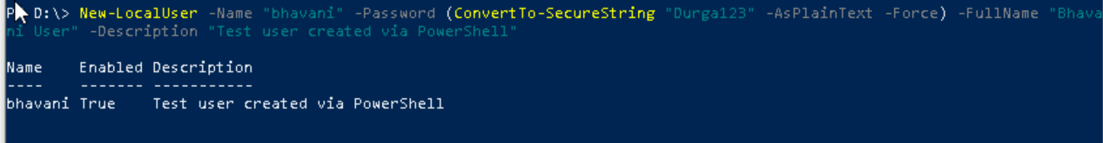

This is the command in the Windows powershell

Task 14:

Can you change the password of a user?

How do you do that? Plz share ss



Set-LocalUser -Name "bhavani" -PasswordNeverExpires $false -UserMayChangePassword $true

Task 15:

What is diff between Process and Thread?

Process – This is a program that is running and It has its own memory, own CPU time and work like an independent.

Ex : If we open chrome, it starts as a process , if we open another tab it run in a separate process.

Thread: It is like a mini-task inside a process. It shares the memory with the process.

Ex: Inside chrome, if one tab is loading a page and another is checking updates these task be handled by a thread.

Process run the program and thread is a small task inside the process.

Process had it own program and thread shares memory with other threads.

Process speed is slow to start and thread is faster to start.

Process communication is harder and thread is easier.

Ex:

Chrome (browser) = Process

Each tab = Thread

Each extension = Another thread

Task 16:

Doc 14 Linux Grep commands in docs to study folder .. plz work on it..

Done

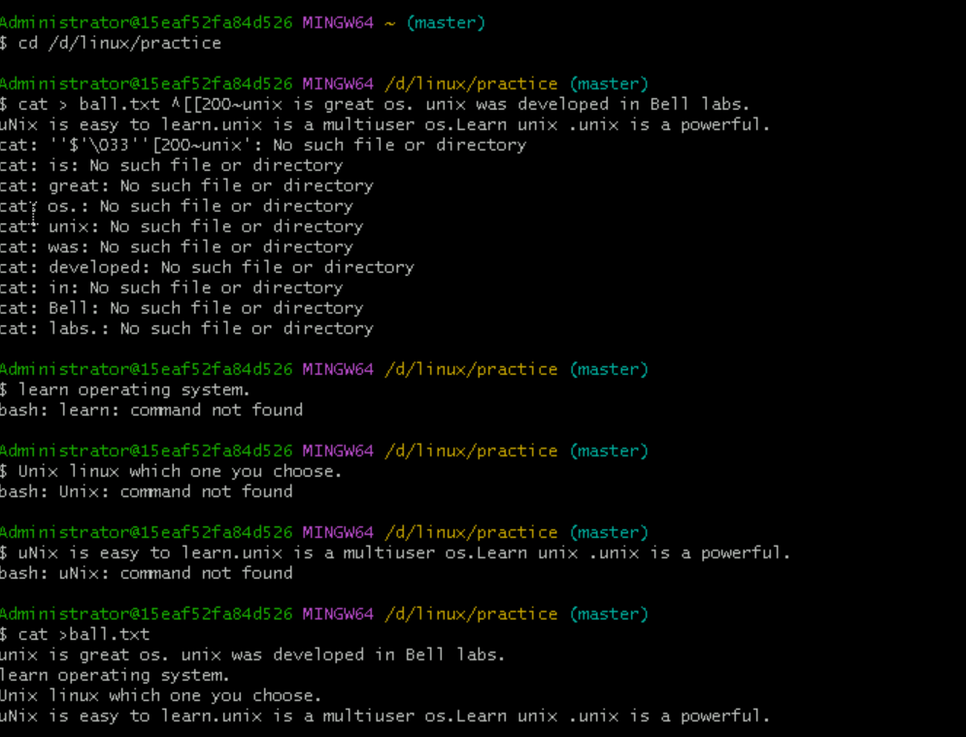

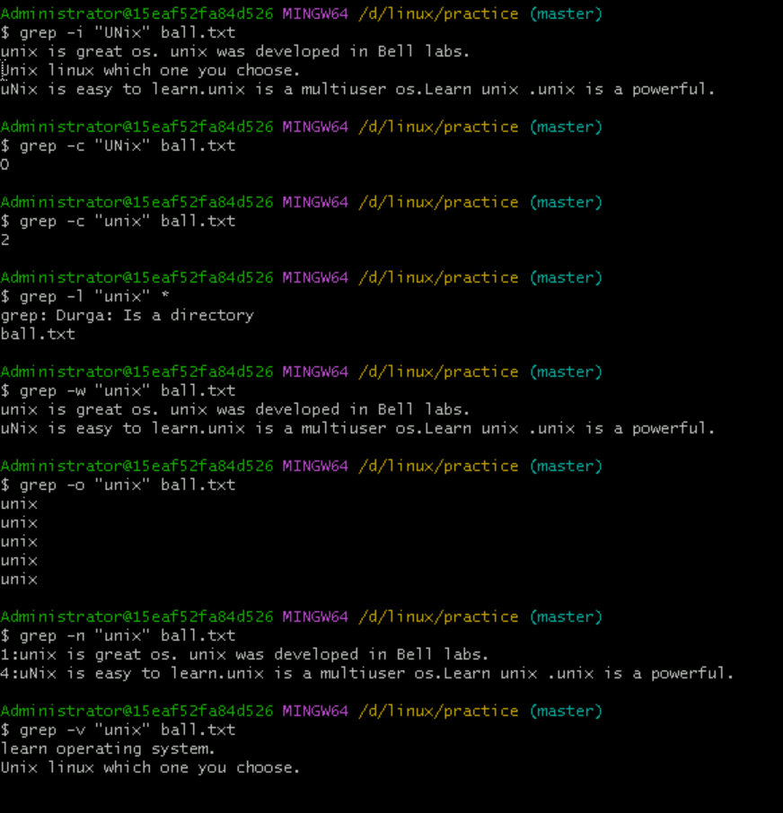

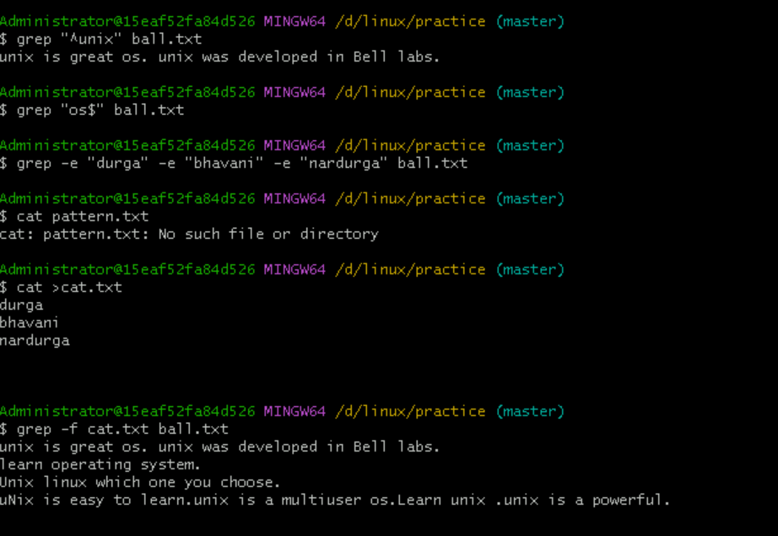

Task 18:

How to check file access permission in Linux?

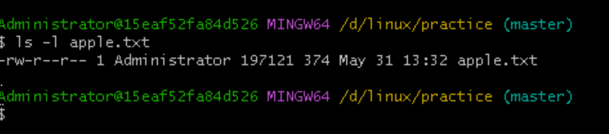

Task 19:

What are the default permissions for a new file ?

Plz find out for

Owner   → read and write rw-

Group → read r--

All and others → read r—

Task 20:

What is the command to change the permisssion to read only for the owner, group and all other users

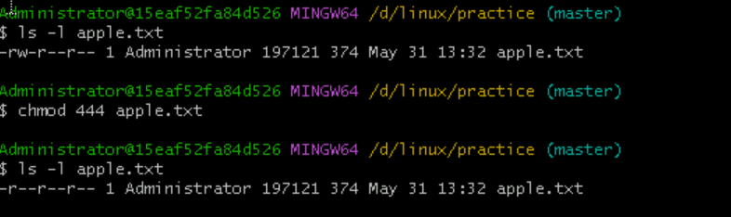

Task 21:

Can you change the file permissions to match the following:

* owner: Read and Write -6
* group: Read -4
* other: no permissions (None) - 0

Task 22:

What was the command for changing the file permissions to -rw-r-----?

Hint : use chmod 640 filename

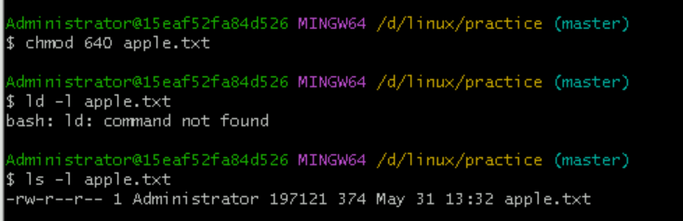

Task 23:

Change chmod.exercises permissions to -rwxr-x--x

Change the file permissions to match the following:

owner: Read, Write and Execute - 7

group: Read and Execute -5

other: Execute -1

Task 24:

What was the command for changing the file permissions to -rwxr-x--x

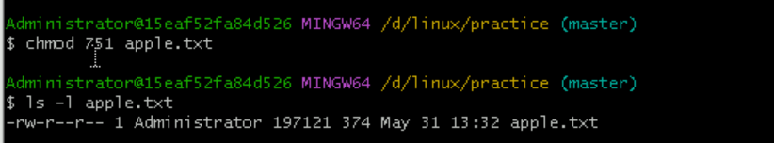

Task 25:

Guys what will this command do?

chown -c master file1.txt

Change the owner of file1.txt to master and give successful output.

Task 26:

Can you define what is  a process